Remote administration preparations for examinees

Over the last weeks, we have all been operating a little bit different — adjusting our normal routines, altering our perspectives, and in some cases quickly learning to do things in a whole new way. While so much has undoubtedly changed, one thing is for certain... your students and clients still need you.

If you’ve chosen to use remote administration to continue to serve your students and clients, their preparations before the session will increase your quality time with them during the session. Please feel free to share these tips with them before you meet remotely.

Hello [Examinee Name],

I am looking forward to working with you! Please prepare for our [appointment/session] by getting an assessment “space” set up and ready to go.

Assessment environment
- Distractions
- Please turn off radios, televisions, cuckoo clocks, or anything that makes sounds or can create a visual distraction.
- Please make sure the dog, the baby, the bird, and any other people have left the room.
- Be sure to move any food or drinks to another room.
- Lighting
- Eliminate any extreme lights shining on your computer screen or in the background.
- Make sure you have plenty of light to see your work materials.
- Seating
- Use a comfortable upright chair such as a kitchen or desk chair — not a bean bag or lounge chair.
- Sit at a place with a stable surface, such as a table or desk.

Computer
- Please have your computer fully charged AND plugged in.
- Set your computer display to full brightness.
- Adjust your computer speaker volume to a comfortable level.
- If possible, use stereo headphones.
- Ensure you are on a stable internet connection.
- Be ready to open your email to participate in some assessment processes.

Prepare a modified document camera
- Have a portable, WiFi-enabled device such as a smartphone or tablet with a
camera at the ready.
- Fully charge the device and connect it to a power source throughout the test
session.
- Ensure you can access your email from this device.
- From the device’s settings, turn off the microphone and speaker, leaving your
computer microphone or speaker on.
- Lock the screen orientation to “Portrait”.
- Set up a separate platform at least 10 inches from the work surface to rest your
so you don’t have to hold it. Position the camera so it is pointing to your computer
screen. You need to have the ability to move your camera so that I can see what
you are pointing to on the screen or to show written responses on a page. You
may find the following supplies helpful:
- Ruler
- Rubber band
- Tape
- Can
- Book
- Stack of books to build a tower
- Box of cereal or rice or a jar full of marbles

An example: Ensuring the camera is not blocked, rubber band the camera to a ruler, paint stick or spatula, then put the ruler in a can that is taped to a book or within a stack of books. (I used tape in this image because I did not have a rubber band. A rubber band is preferred.)
See pictures:

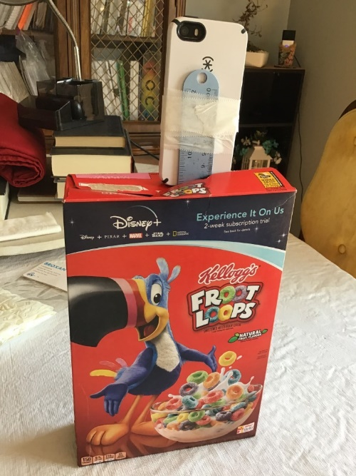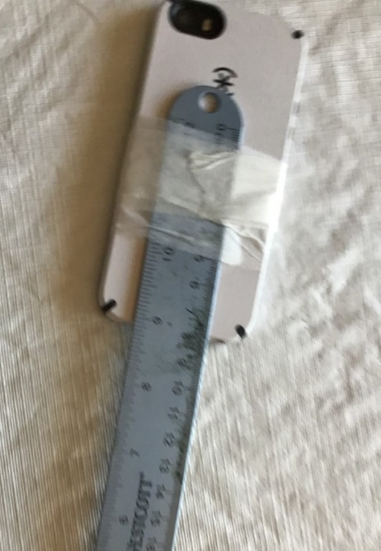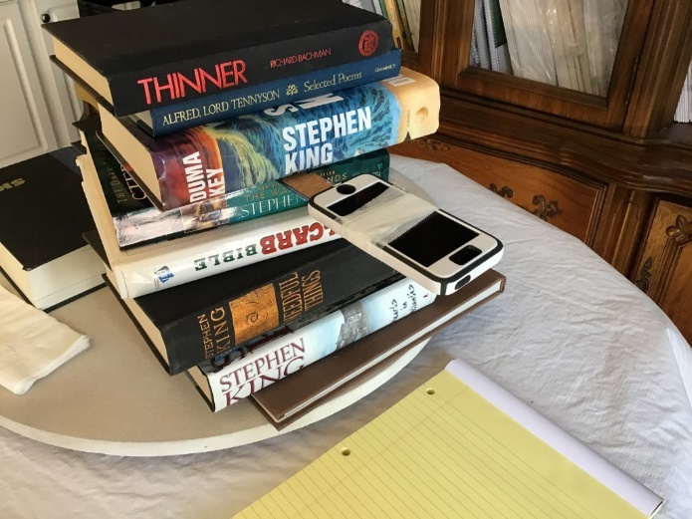

Gather other supplies that may be needed:
- Pencil with eraser
- Ink pen
- Scratch paper

That’s all! I look forward to our session and “seeing” you soon!

[Your name]

