
How to Change Account Ownership
Digital Assessment Library (DALS)

Digital Assessment Library (DALS):
How to Change Account Ownership

To update the Account Owner for your Digital Assessment Library for Schools accounts, Pearson requires a signed request on official letterhead.

Required Letter Criteria
- Must be on organization letterhead
- Must be signed by an authorized individual (e.g., Superintendent, Director, Commander)
- Must request ownership change for DALS
- Must reference Q global and/or Q interactive, as applicable
- New owner must meet qualification requirements.
In most instances, Account Owners listed for Q‑interactive and Q‑global must hold a Level C qualification (typically a School Psychologist or similarly credentialed clinician) and have it on file with Pearson.
Administrators who do not hold a Level C qualification may be added to the account after setup with administrative permissions, as appropriate.
For qualification details, visit pearsonassessments.com/qualifications or see instructions at the back of this document.

How to Find Your Account Numbers (If Needed)

Q global Account Number
The Inventory Account Number is required to identify the account for which you wish to update the ownership.
To locate your Q global account number:
- Sign in to Q global
- Click Manage Accounts at the top of the page
- Click the Account Name to open the Account Details page
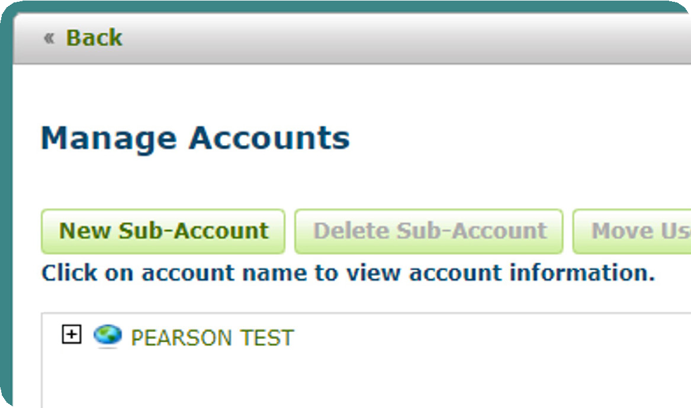
Result:
The Account Number is listed directly under the Account Name.
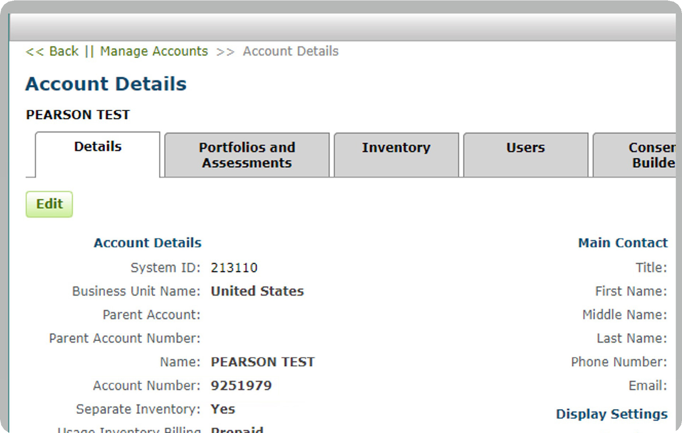

Q interactive Account Number
The Q interactive account number is typically the organizational Pearson account number used when placing orders and can usually be found on:
- Quotes
- Invoices
- Order confirmations

Need Assistance?
If you need help locating account information, please contact:
Pearson Assessments Customer Support
800 627 7271
A support agent can assist with identifying the correct account details.

DALS Account Ownership Change Request Template
Copy/Paste the template on the next page onto your organization letterhead. Letterhead must be signed by someone in management at the organization, such as the superintendent, commander, or director.
[Date]
Pearson Assessments – Customer Support
Re: DALS Account Ownership Change
I am writing to formally request a change of Account Ownership for our Digital Assessment Library for Schools (DALS) accounts. This request is submitted on official organization letterhead and is authorized by district leadership.
Organization Name:
Pearson Customer / Organizational Account (if known):
Q interactive Account Ownership Change
- Q interactive Account Name:
- Q interactive Account Number:
Current Q interactive Account Owner
- Name:
- Email:
New Q interactive Account Owner
- Name:
- Email:
Q global Account Ownership Change
- Q global Account Name:
- Q global Account Number:
Current Q global Account Owner
- Name (First and Last):
- Email Address:
New Q global Account Owner
- Name (First and Last):
- Email Address:
Qualification Acknowledgement
YES / NO I confirm that the new Account Owner(s) listed above meet Pearson’s qualification requirements for access to professional assessment materials.
Authorization
Signature of Authorized Supervisor:

Printed Name and Title of Supervisor:

Primary Contact for This Request
Contact Name:
Organization:
Phone:
Email:
Submit completed letter via email to clinicalcustomersupport@pearson.com with subject line:
DALS Account Ownership Change

How to Submit Qualifications – pearsonassessments.com
The account owner must be a Level C qualified user (for additional information, please see our Qualifications Policy). To quickly upload your qualifications to our system, please follow the instructions below:

If you are NEW to pearsonassessments.com:
- Create an individual account at pearsonassessments.com
Please use work email address as this is how Pearson will connect your qualifications in our system.
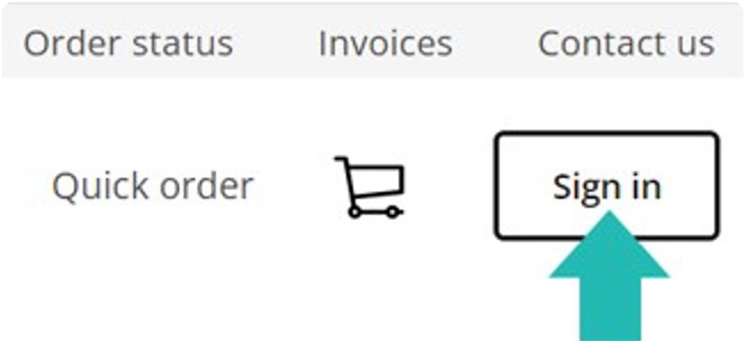
- Link to organizational account, the Pearson account used when placing orders – account number is found on quotes, invoices, etc.
- Follow the prompts to establish user qualifications
- If the site gives you an “A” level qualification, please do the following:
- While signed in, click the circle with your initials in the top-right of the screen
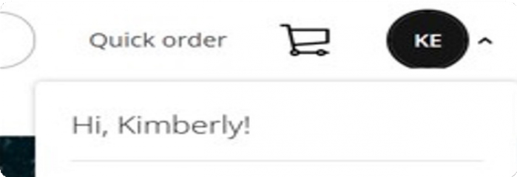
- From the drop-down, click on “Qualifications”
- Here you can provide Qualification information, such as Degree, License / Certification, etc.
- Click on the “i” to the right of the qualification section for additional information about professional information and how it corresponds to the qualification level for that category.
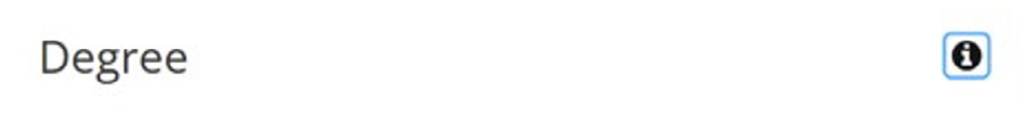

If you are an EXISTING user and already have a login for pearsonassessments.com:
- Log into your individual account at pearsonassessments.com
- Once logged in, hover over the circle with your initials in the top-right corner of the screen:
- Click on “Accounts” to make sure you are linked to your organization’s account. This is the Pearson account used when placing orders – account number is found on quotes, invoices, etc.
- Click again on the circle with your initials in the top-right corner of the screen. This time choose “Qualifications.”
- Follow the prompts to establish user qualifications
- Here you can provide Qualification information, such as Degree, License/Certification, etc.
- Click on the “i” to the right of the qualification section for additional information about professional information and how it corresponds to the qualification level for that category.

